Renju lesson on October 4, 2001
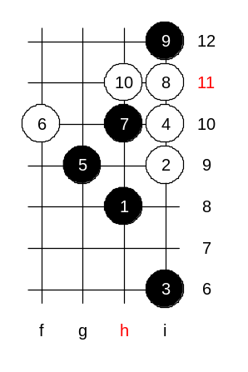
Hello everyone! Welcome to Online Renju Class. We will now begin. Today we will continue the study of i8 opening. Let us continue checking same 4th move as last time – i10. Now it is time to study the most usual 5th move here – g9. What is the best 6th move here? Everybody says 6-h10. So, may I ask you, is there any other 6th move possible? Can 6-f10 protect? Let’s test it though, to make sure about it. Lets see how many correct suggestions for 7th move. Wow, so many of you suggest h10. But 7-h10 loses.

So, the correct 7th move is…? Yes, i8, it is the winning move.
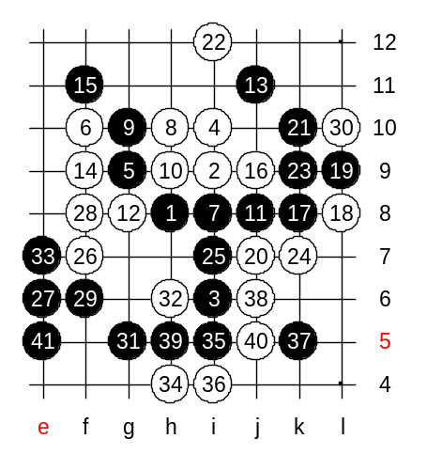
Let us try to make the strongest resistance for whites. I think g8 is not so strong because then black can play 9-j6 with control style. Therefore, let’s try 8-h10. How should black escape from 3x3 now? Thank you, most of you suggested j8 as a next move. Thanks, you have chosen the strongest moves. But it is not quite over yet. White can still struggle. 14-f9 seems to be the strongest – it forces black to defend above. How to continue?
We need to worry about the open lines as well as the potential development point i7. I guess our choices for next move are k8, j9, i7. Which one? OK, we try j9. See what happens. Black had straight VCT.
Now, are you all convinced about the black win after such 6th move?

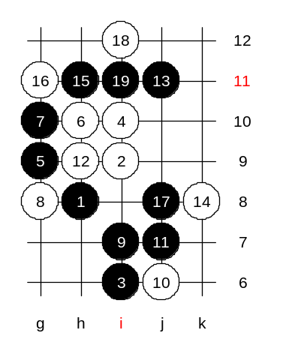
Lets continue with 6-h10. It is the only move that does not lose so fast. Since there are so many variants, we are not very sure of 100% black win. Before we go to the main 7th move that is 7-f10, I want to introduce you one of my old analyses. That is about 7-g10. White is forced to play g8 here. 11-j7! – a key of my analysis. I discovered this move many years ago. White’s 12-k7 leads to black win. There is one defense move though. Even “Click of stones” had published that variant of my analysis. Moves 12-h9 and 14-k8 are the defense moves. Since black does not have VCT, it must continue with positional style – h11. Then, white is forced to balance – g11 and i12. What can you say about the outcome? Yes, it seems both black and white are active, and both have equal chances. In the old times, I tried to analyse a bit further, but it all became too messy, and I stopped the search.

Let’s go to the main 7th move. All the moves up to the 16th are forced.
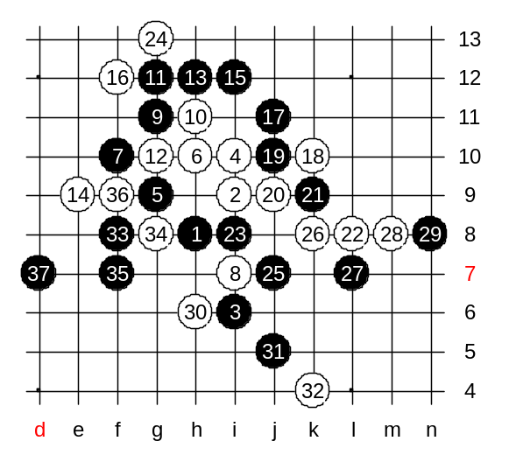
This is the main variant of the 4th move. It is considered to be almost black win. There are two choices of 17th moves to be played. Do you know them? Those who offered j11, j10 are correct. Nowadays the 17-j11 is the most popular. How does the main variant continue? We have two choices for 22nd move. Let us try the 22-L8. We can play either 24-g13 or h13. Move 28-m8 tries to separate two sides. The following moves are the example from the Russian game. The win here had been found by Russian players. After the 37th move black wins soon, using the positional advantage below. See the connection that begins from k6. It helps the left side attack.
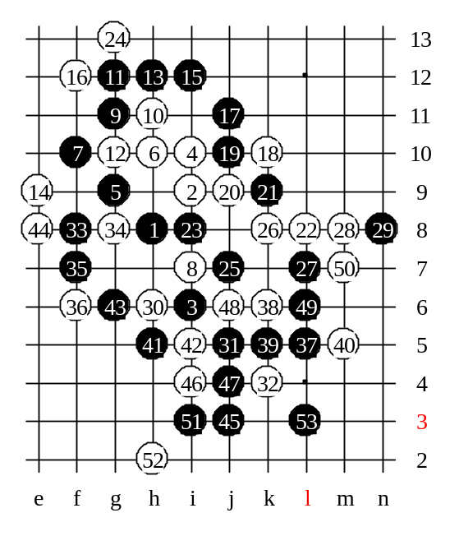
We will show the win in case of another 36th move too. Fast, without comments.
Note that if white had played i4 instead of 8 then black would win easily by d9 and d7.

The lesson is over now! Thank you all for coming. See you next week! Thank to all helpers, you were all great! :)

